PJ-B551P-V7L
LCD FHD
Narrow bezel panel
For video wall

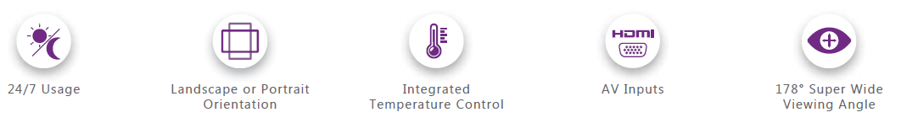
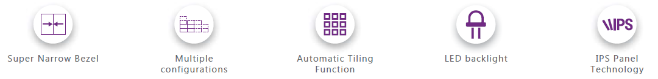

Model No. | PJ-B551P-V6L
View Area(L*H) (mm) | 1209.6*680.4
Outer case size(mm) | 1210.51×681.22×123mm
N.W.(kgs/unit) | 28.8
Panel specifications
Panel Size | 55inch
Backlight | LED
LCD panel Brand | LG
Panel No | LD550DUN-TMA4
Brightness | 500cd/m2
bezel for combined two panels | 0.88mm
Contrast Ratio | 1100 : 1
Resolution | 1920*1080
Viewing Angle | 178°/178°(H,V)
Color | 10Bit (D), 1.07 Billion colors. 72% NTSC
Response Time | 8ms
Refresh Rate | 60Hz
Using life | 50,000(hrs)
Power
Power supply | AC100V-240V, 50/60Hz
Max Power consumption | 170W
Standby power consumption | 0.5W
Video wall controller( Built in each screen)
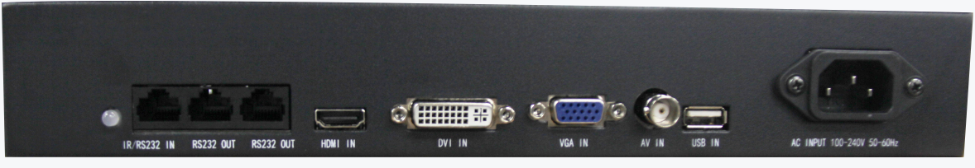
DVI in | 1 (MAX 1920 X 1080 @60 HZ input support)
HDMI in | 1 (MAX 3840 X 2160 @30 HZ input support)
VGA in | 1 (MAX 1920 X 1080 @60 HZ input support)
AV in | 1(BNC, NTSC, PAL support)
USB | 1
RS232 In | 1
RS232 Out | 2
Control signal input and loop out | RS232 In&Out
Control interface | remote controller or RS232
Video system
Color system | PAL/NTSC/SECAM
3D comb filter and video comb filter | Yes
OSD Language | English Chinese; (to be available in multiple languages)
Temperature
Working temperature | 0 ℃ ~ 50 ℃ (no condensation)
Working humidity | 10% ~ 90% (no condensation)
Accessories
User Manual ,power cable,, RJ45 cable, IR receiver, remote controller, HDMI/DVI cable, USB-RS232 converter, RS232 to RJ45 converter
Partner with
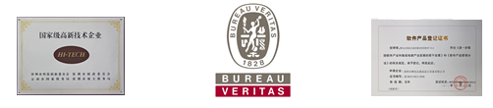

Real Picture
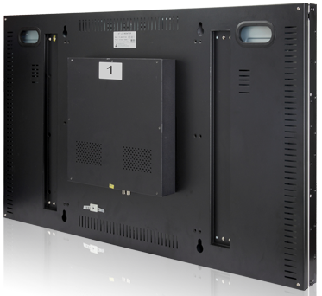
Project Pictures
